1. Consider a case, a folder has multiple files and how would copy it to destination machine path (Try using SCP, cp options in Linux)

scp -r /home/rohansteven/source_folder rohan@localhost:/home/rohan/destination_folder

cp ~/my_folder/testfile.txt "/mnt/c/Users/ROHAN STEVEN/OneDrive/Desktop/"

2. Host a FTP and SFTP server and try PUT and GET operations.

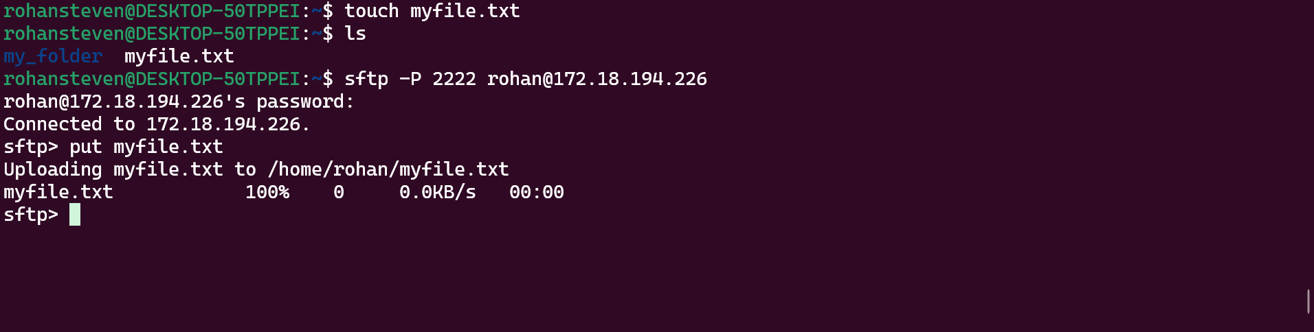

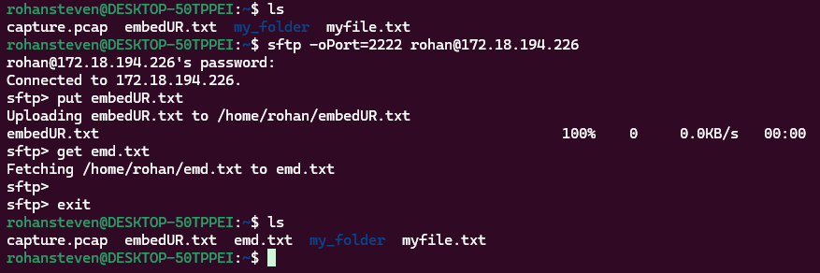

Output



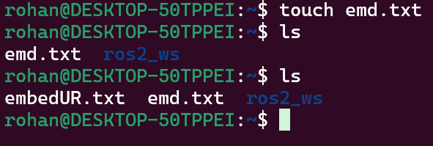

3. Explore with Wireshark/TCP-dump/cisco packet tracer tools and learn about packets filters.

rohansteven@DESKTOP-50TPPEI:~$ sudo tcpdump -i eth0 -w capture.pcap

rohansteven@DESKTOP-50TPPEI:~$ wireshark &

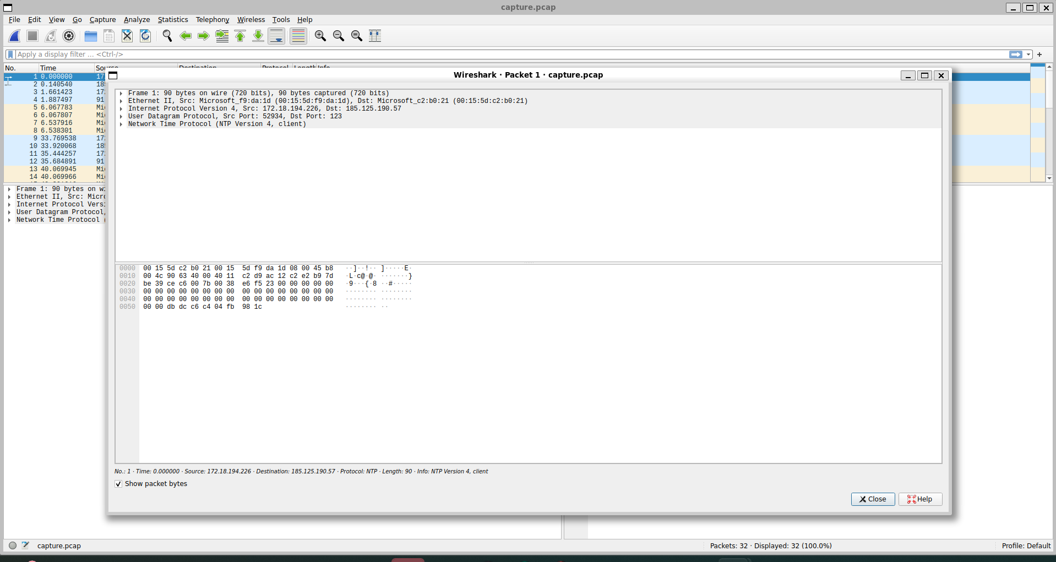

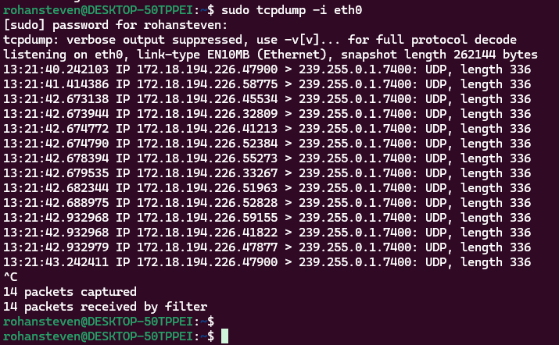

4. Understand linux utility commands like - ping, arp (Understand each params from ifconfig output)

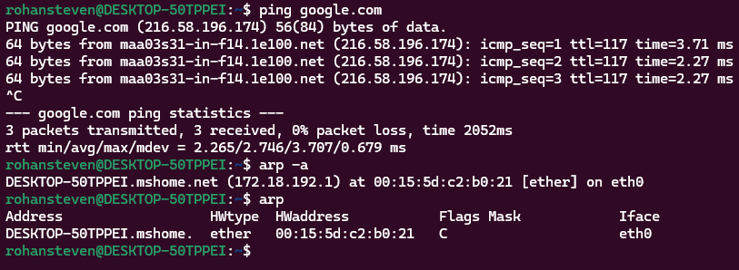

5. Understand what happens when duplicate IPs configured in a network.

**A). Static IP Conflict with DHCP-Assigned IP**

* A device is manually assigned an IP (static), but the same IP is later assigned by the DHCP server to another device.
* Results: One or both devices lose connectivity or get network errors.

**B). Duplicate Static IP Addresses**

* Two devices are manually configured with the same IP.
* Results: Both devices may **intermittently lose connectivity** or experience network instability.

**C). DHCP Assigning Same IP to Multiple Devices**

* Happens due to **misconfigured or malfunctioning** DHCP servers.
* Results: Both devices may face **intermittent or no network access**.

**D). Cloned MAC Address Issue**

* If two devices have the same MAC address (e.g., in virtual machines or network adapters), the DHCP server may assign the same IP to both.
* Results: Network packets get misrouted, leading to **erratic connectivity**.

**Network Disruptions**

* Devices will **randomly disconnect and reconnect**.
* Some services (like SSH, web servers) might **become inaccessible**.

**Effects of IP conflict**

**ARP (Address Resolution Protocol) Conflicts**

* Devices send **conflicting ARP replies**, making network switches route packets incorrectly.
* May cause **packet loss and latency issues**.

**⚠️ Security Risks**

* Attackers could **intentionally assign a duplicate IP** for a **Man-in-the-Middle (MITM) attack**.
* Sensitive data could be intercepted.

**⚠️ Difficulty in Network Troubleshooting**

* IT admins may struggle to diagnose connectivity issues due to inconsistent device behavior.

6. Understand how to access remote system using (VNC viewer, Anydesk, teamviewer and remote destop connections)

Linux to windows: rdesktop -u username remote_host_ip

Windows to linux - remmina

7. How to check your default gateway is reachable or not and understand about default gateway

rohansteven@DESKTOP-50TPPEI:~$ ip route show # Shows the default gateway

default via 172.18.192.1 dev eth0 proto kernel

172.18.192.0/20 dev eth0 proto kernel scope link src 172.18.194.226

8. Check iwconfig/ifconfig to understand in detail about network interfaces (check about interface speed, MTU and other parameters)

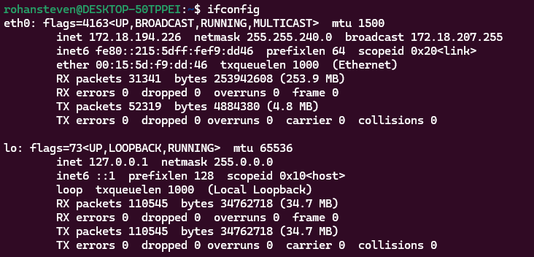

10. Explain how a DHCP server assigns IP addresses to devices in your network.

* Steps:
  1. Device sends a DHCP Discover request.
  2. Server responds with a DHCP Offer.
  3. Device sends a DHCP Request.
  4. Server sends a DHCP Acknowledgment.

11. Using a terminal, connect to a remote machine via SSH and telnet

SSH: ssh [rohansteven@172.18.194.226](mailto:rohansteven@172.18.194.226)

telnet: telnet 172.18.194.226